CITATION
Dr. Shenggen Fan
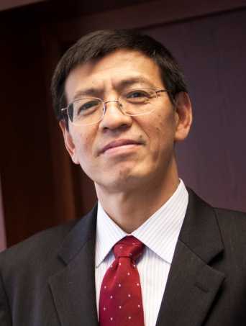
Dr. Shenggen Fan is an accomplished agricultural economist renowned not only as an author of widely cited journal articles and books but also as a global leader in agricultural and food policies. Through decades of research, he has been playing a crucial role in improving food and nutrition security in several countries and regions.
Dr. Fan is currently the Chair Professor at the College of Economics and Management at China Agricultural University (CAU), leading a national innovation team on food economics and policy. Prior to joining CAU, Dr. Fan served as Director General of the International Food Policy Research Institute (IFPRI) from 2009 to 2019. He joined IFPRI in 1995 as a research fellow, and conducted extensive research on pro-poor development strategies in Africa, Asia, and the Middle East, especially in China and India. He led IFPRI’s program on public investment before becoming the Director of the Institute’s Development Strategy and Governance Division in 2005.
Dr. Fan’s research covers a wide range of issues such as public investment, agricultural and rural development, transition economies, poverty reduction, food security and nutrition, and sustainable food systems. He has been engaged in the agricultural development strategy for developing countries throughout his career. The econometric model he developed to measure public investment and priorities in his early years has been set as a paradigm by international agencies such as United Nations and the World Bank and adopted by many developing countries in making policies to optimize public spending and eliminate poverty. As the Director General of IFPRI, he led a strong team of researchers to provide cutting-edge evidence-based research to develop policies towards transforming the food systems for human and planetary health. Dr. Fan was awarded an honorary life membership of the International Association of Agricultural Economists (IAAE) in 2018 and became a Fellow of American Applied Economics Association (AAEA) in 2020.
In addition to academic achievements, Dr. Fan champions food security and nutrition and innovative food systems through his leadership role on multiple global committees. He has been a member of the Lead Group for the Scaling Up Nutrition (SUN) Movement appointed by the former UN Secretary General Ban KiMoon, and he served as the chair, the vice-chair, and member of the Food and Nutrition Council of the World Economic Forum from 2012 to 2018. He also serves as an adviser to many national governments on agriculture, food security, and nutrition related matters.
Dr. Fan has made tremendous contributions to eradicate hunger and to ensure food security all over the world. He received the Hunger Hero Award from the World Food Program in recognition of his commitment to and leadership in fighting hunger worldwide in 2014. In 2017, Dr. Fan received a highly prestigious Fudan Management Excellence Award in 2017 - a highly prestigious award, recognizing individuals who have made outstanding contributions in the field of management, is regarded as a “Nobel Prize for Management” in China.
As Director General, IFPRI, Dr Fan tried to build a very strong and ambitious program on good policy and nutritional security research in India as well as South Asia. TAAS is pleased to bestow prestigious Dr Swaminathan award on Dr Shenggen Fan for his lifetime outstanding contributions.

